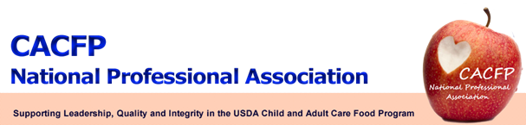

May 2012 Message of the Month

2012 CACFP NPA Conference – April 11-13, 2012
We hope that everybody enjoyed the conference and made it home safe. Conference presentations are now available on our website for view under the member’s link http://www.cacfpnpa.org.
CACFP NPA Membership
Minutes of the Biennial Conference membership meeting are now available for review and final approval at http://www.cacfpnpa.org. If you have any comments, please email it to your Regional Representative.

Board Vacancies:
Members are strongly encouraged to run and/or nominate colleagues for Board vacancies. Six vacancies are open on the Board for 2012-13. They include:
President-elect - a three-year commitment that requires a candidate to have at least two years experience working in the CACFP; and
Treasurer – a two-year commitment requiring a candidate to have one year working directly in the program.
Four Regional Representative positions – Northeast, Mid-Atlantic, Midwest and Mountain Plains regions - representatives serve a term of two years and must have one year’s experience in the CACFP.

Membership Renewal:
Remember that you can still renew your two year membership for 2011-2013. The membership form can be found on the CACFP NPA website, http://www.cacfpnpa.org/2011-2013%20Membership%20Form%20State%20Agency.doc.
USDA Update

The proposed rule titled “Child and Adult Care Food Program: Amendments Related to the Healthy, Hunger- Free Kids Act of 2010” was issued on April 9, 2012, and can be found at the following link: http://www.fns.usda.gov/cnd/care/Regs-Policy/policymemo/CACFP_Amendments_Rule.pdf.

This rule proposes to codify several provisions of the Healthy, Hunger-Free Kids Act of 2010 that affect the management of the CACFP. Members are encouraged to review the proposed rule and take the opportunity to provide comment directly to the U.S. Department of Agriculture (USDA). All comments must be received by USDA on or before June 8, 2012.

